**1. Wealth Management Operations**

**2. Treasury Management Services**

**3. Risk Management in Banking Operations**

**(Presented By Alan Stuart K)**

**1. Wealth Management Operations:**

**Introduction**:  
Wealth management operations involve providing financial services and advice to high-net-worth individuals (HNWIs) and institutions. These services include investment management, financial planning, estate planning, tax services, and retirement planning. The goal is to grow and preserve wealth over the long term while meeting the specific financial goals and risk tolerance of clients.

**Basic Terminologies**:

* **Assets Under Management (AUM)**: The total market value of assets that a wealth management firm manages on behalf of its clients.
* **Portfolio Management**: The process of selecting, managing, and overseeing a collection of investments to meet specific financial goals.
* **Diversification**: A risk management strategy that involves spreading investments across various asset classes to reduce risk.
* **Asset Allocation**: The process of dividing an investment portfolio among different asset categories, such as stocks, bonds, and cash.
* **Financial Planning**: A comprehensive evaluation of an individual's current and future financial state by using currently known variables to predict future cash flows, asset values, and withdrawal plans.
* **Estate Planning**: The process of arranging for the disposal of an individual's estate, including the management of assets and liabilities after death.
* **Tax Efficiency**: Strategies to minimize tax liabilities and maximize after-tax returns on investments.
* **Retirement Planning**: The process of determining retirement income goals and the actions and decisions necessary to achieve those goals.

**Graphs:**

**Graph 1.A:** Wealth Management Operations: Adjusted Close Prices:

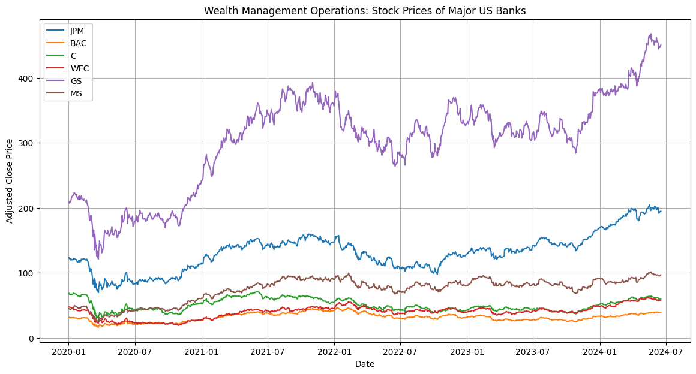**Inference**:

* **Trend Analysis**: The adjusted close prices provide insights into the stock performance of each bank over the specified period.
* **Performance Comparison**: By comparing the stock prices, we can identify which banks have performed better or worse relative to their peers.
* **Market Sentiment**: Significant price movements can indicate market sentiment, investor confidence, and reactions to economic events or bank-specific news.
* **Investment Decisions**: Investors can use this information to make informed decisions about buying, holding, or selling stocks.

**Graph 1.B:** Wealth Management Operations: Market Capitalization:

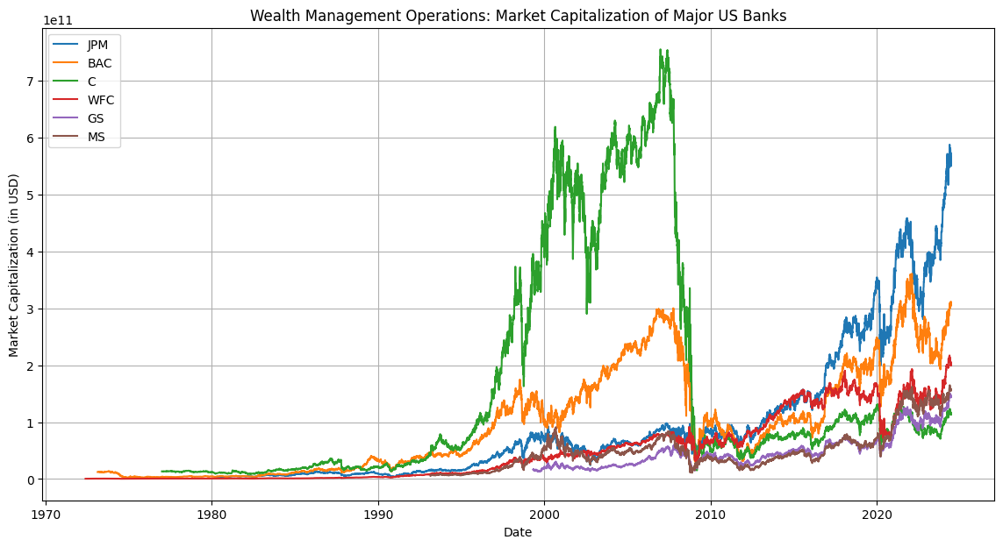**Inference**:

* **Company Valuation**: Market capitalization represents the total market value of a company's outstanding shares. It provides a snapshot of the bank's size and market value.
* **Growth Analysis**: Changes in market capitalization over time can indicate growth or decline in the bank's value, influenced by stock price movements and changes in the number of outstanding shares.
* **Comparative Analysis**: Comparing market capitalizations helps identify the relative size and market position of each bank within the industry.

**Graph 1.C:** Wealth Management Operations: Price-to-Earnings (P/E) Ratio:

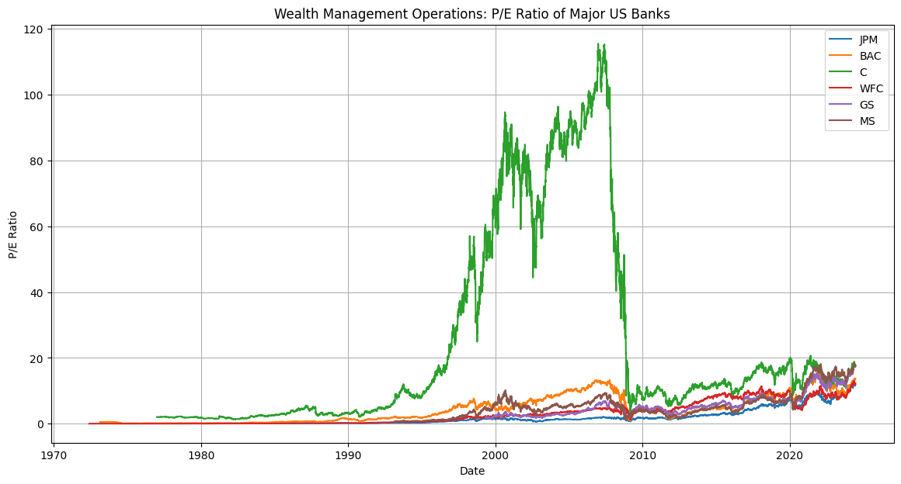**Inference**:

* **Valuation Metric**: The P/E ratio is a common valuation metric that compares a company's stock price to its earnings per share (EPS). It indicates how much investors are willing to pay for each dollar of earnings.
* **Growth Expectations**: A higher P/E ratio can indicate higher growth expectations, while a lower P/E ratio may suggest undervaluation or lower growth prospects.
* **Comparative Valuation**: By comparing P/E ratios, investors can assess the relative valuation of each bank and identify potential investment opportunities.

**2. Treasury Management Services:**

**Introduction**:  
Treasury management services involve managing a company's liquidity, funding, and financial risk. These services are crucial for ensuring that a company has sufficient cash flow to meet its obligations, optimize its financial resources, and manage risks associated with currency fluctuations, interest rates, and other financial variables.

**Basic Terminologies**:

* **Liquidity Management**: The process of ensuring that a company has enough cash or liquid assets to meet its short-term obligations.
* **Cash Flow Forecasting**: Predicting the future cash inflows and outflows to ensure that a company can meet its financial obligations.
* **Working Capital**: The difference between a company's current assets and current liabilities, representing the short-term financial health of the company.
* **Treasury Bills (T-Bills)**: Short-term government securities with maturities ranging from a few days to one year, used for managing short-term liquidity.
* **Commercial Paper**: An unsecured, short-term debt instrument issued by corporations to meet short-term liabilities.
* **Foreign Exchange (FX) Risk**: The risk of loss due to changes in exchange rates affecting the value of foreign currency transactions.
* **Interest Rate Risk**: The risk that changes in interest rates will affect the value of financial instruments or the cost of borrowing.
* **Hedging**: Using financial instruments or strategies to offset potential losses in investments or transactions.

**Graphs:**

**Graph 2.A:** Treasury Management Services: Trading Volume:

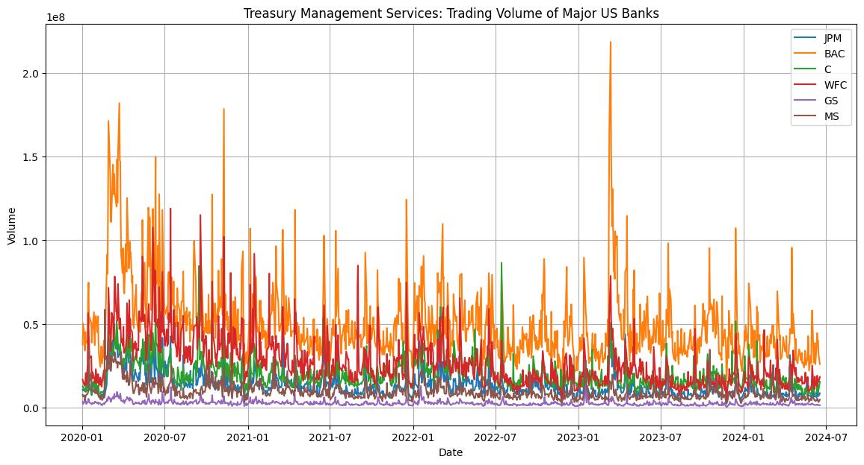**Inference**:

* **Liquidity Analysis**: Trading volume is a proxy for liquidity. Higher trading volumes indicate higher liquidity, making it easier to buy or sell shares without significantly affecting the stock price.
* **Market Activity**: Spikes in trading volume can indicate increased market activity, often associated with significant news or events affecting the bank or the broader market.
* **Investor Interest**: Consistently high trading volumes can suggest sustained investor interest and confidence in the bank.

**Graph 2.B:** Treasury Management Services: Daily Returns:

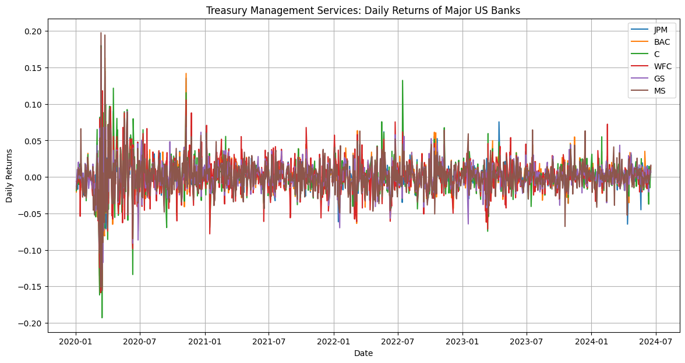**Inference**:

* **Volatility and Risk**: Daily returns provide insights into the day-to-day volatility and risk associated with each bank's stock.
* **Performance Evaluation**: By analyzing daily returns, investors can evaluate the short-term performance and identify patterns or trends in stock price movements.
* **Market Reactions**: Significant daily returns (positive or negative) can indicate market reactions to news, earnings reports, or economic events.

**Graph 2.C:** Treasury Management Services: Moving Average:

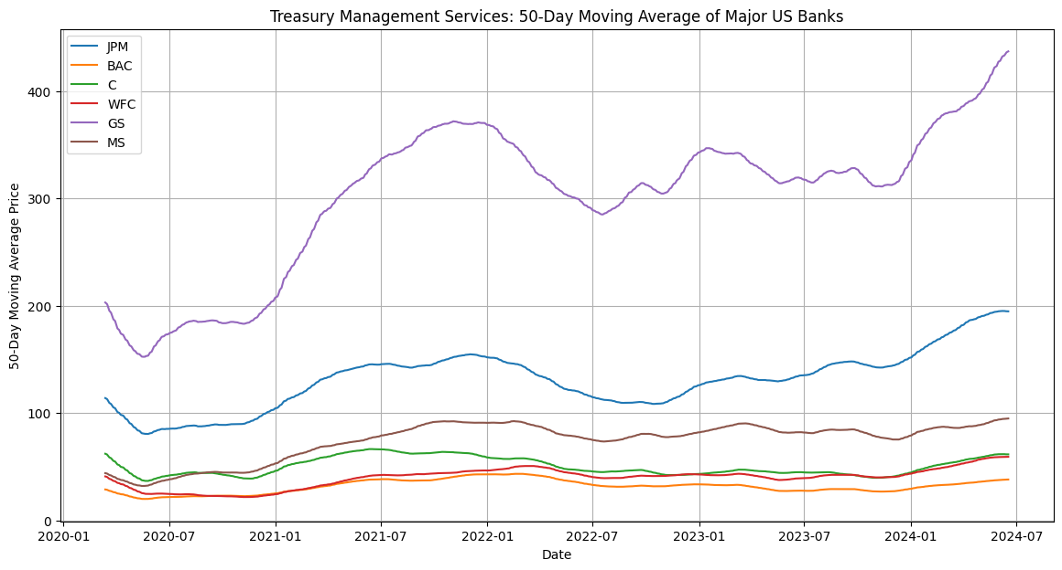**Inference**:

* **Trend Identification**: Moving averages smooth out short-term fluctuations and help identify longer-term trends in stock prices.
* **Support and Resistance**: Moving averages can act as support or resistance levels, indicating potential points where the stock price may reverse direction.
* **Trading Signals**: Crossovers of short-term and long-term moving averages can generate trading signals. For example, a bullish signal occurs when a short-term moving average crosses above a long-term moving average.

**3. Risk Management in Banking Operations:**

**Introduction**:  
Risk management in banking operations involves identifying, assessing, and mitigating risks that could negatively impact a bank's financial health and stability. These risks include credit risk, market risk, operational risk, liquidity risk, and compliance risk. Effective risk management is essential for maintaining the bank's solvency, protecting its reputation, and ensuring regulatory compliance.

**Basic Terminologies**:

* **Credit Risk**: The risk of loss due to a borrower's failure to repay a loan or meet contractual obligations.
* **Market Risk**: The risk of losses due to changes in market prices, such as interest rates, exchange rates, and equity prices.
* **Operational Risk**: The risk of loss resulting from inadequate or failed internal processes, people, systems, or external events.
* **Liquidity Risk**: The risk that a bank will not be able to meet its short-term financial obligations due to an inability to convert assets into cash quickly.
* **Compliance Risk**: The risk of legal or regulatory sanctions, financial loss, or reputational damage due to non-compliance with laws, regulations, or internal policies.
* **Value at Risk (VaR)**: A statistical measure that estimates the potential loss in value of a portfolio over a specified period with a given confidence level.
* **Stress Testing**: A risk management technique that evaluates the potential impact of extreme but plausible adverse scenarios on a bank's financial position.
* **Capital Adequacy**: The requirement for banks to maintain sufficient capital to absorb potential losses and meet regulatory requirements.
* **Basel Accords**: A set of international banking regulations developed by the Basel Committee on Banking Supervision to ensure that banks maintain adequate capital to manage risks.

**Graphs:**

**Graph 3.A:** Risk Management in Banking Operations: Annualized Volatility:

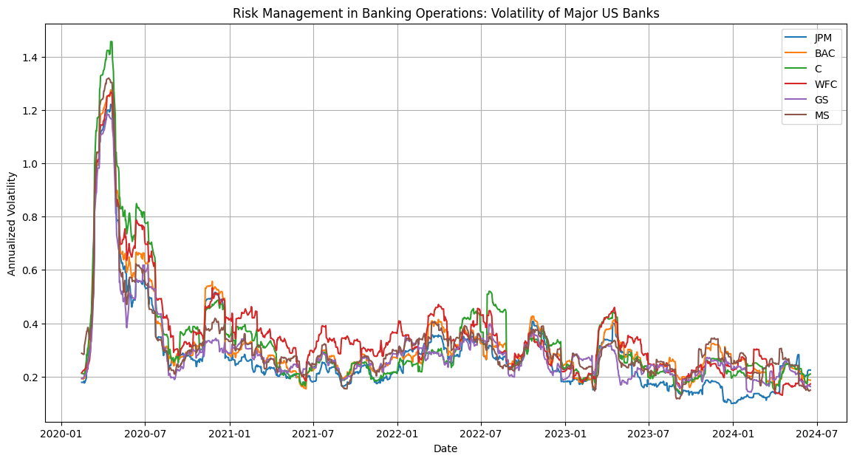**Inference**:

* **Risk Assessment**: Volatility is a measure of risk. Higher volatility indicates higher risk, as the stock price is more likely to experience significant fluctuations.
* **Market Stability**: Periods of high volatility can indicate market instability or uncertainty, while lower volatility suggests a more stable market environment.
* **Investment Strategy**: Investors with different risk appetites can use volatility information to tailor their investment strategies. Risk-averse investors may prefer stocks with lower volatility.

**Graph 3.B:** Risk Management in Banking Operations: Value at Risk (VaR):

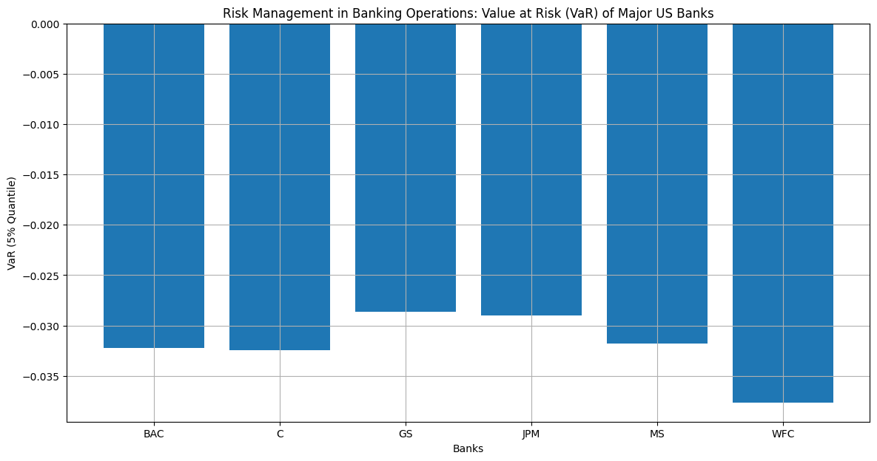**Inference**:

* **Risk Quantification**: VaR quantifies the potential loss in value of a bank's stock with a given confidence level (e.g., 95%). It provides a measure of the maximum expected loss over a specified period.
* **Comparative Risk**: By comparing VaR across banks, investors can assess the relative risk associated with each bank's stock.
* **Risk Management**: Banks and investors use VaR to manage and mitigate potential losses, ensuring they are within acceptable risk limits.

**Graph 3.C:** Risk Management in Banking Operations: Sharpe Ratio:

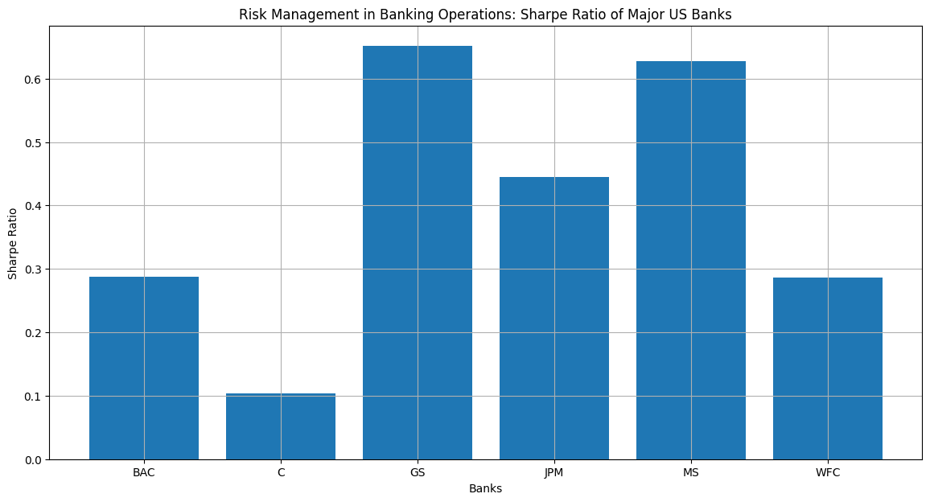**Inference**:

* **Risk-Adjusted Return**: The Sharpe Ratio measures the risk-adjusted return of an investment. A higher Sharpe Ratio indicates better risk-adjusted performance.
* **Comparative Analysis**: By comparing Sharpe Ratios, investors can identify which banks offer the best returns relative to their risk.
* **Investment Decisions**: Investors can use the Sharpe Ratio to make informed decisions about which stocks to include in their portfolios, balancing risk and return.

**Conclusion:**

Wealth management, treasury management, and risk management are vital, interconnected functions within financial institutions, each playing a crucial role in ensuring financial stability, optimizing performance, and managing risks. Wealth management focuses on helping clients achieve their financial goals through personalized strategies and insights from key metrics like adjusted close prices and market capitalization. Treasury management ensures a company's financial health by managing liquidity, optimizing cash flow, and mitigating financial risks, informed by trading volume and daily returns. Risk management protects banks by assessing and mitigating various risks, including credit, market, operational, and liquidity risks, using metrics such as annualized volatility and Value at Risk (VaR). By integrating these disciplines, financial institutions can deliver comprehensive and resilient financial solutions, enhancing decision-making, optimizing performance, and building a robust foundation for future growth.